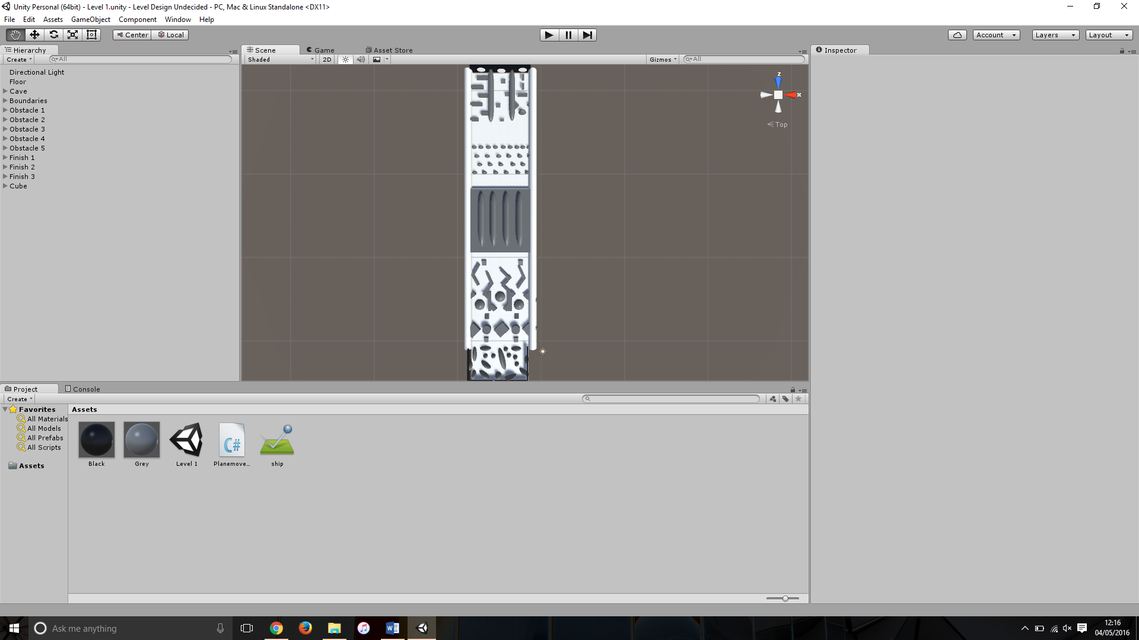Level Design Development Report

This report is intended to outline the development that took place, in regards to level design, to get to the final track used in the game handed in for assessment. I will cover the original design plans, the original models, briefly mention models from artists and the balancing procedures that I went through to make the game playable and fun.

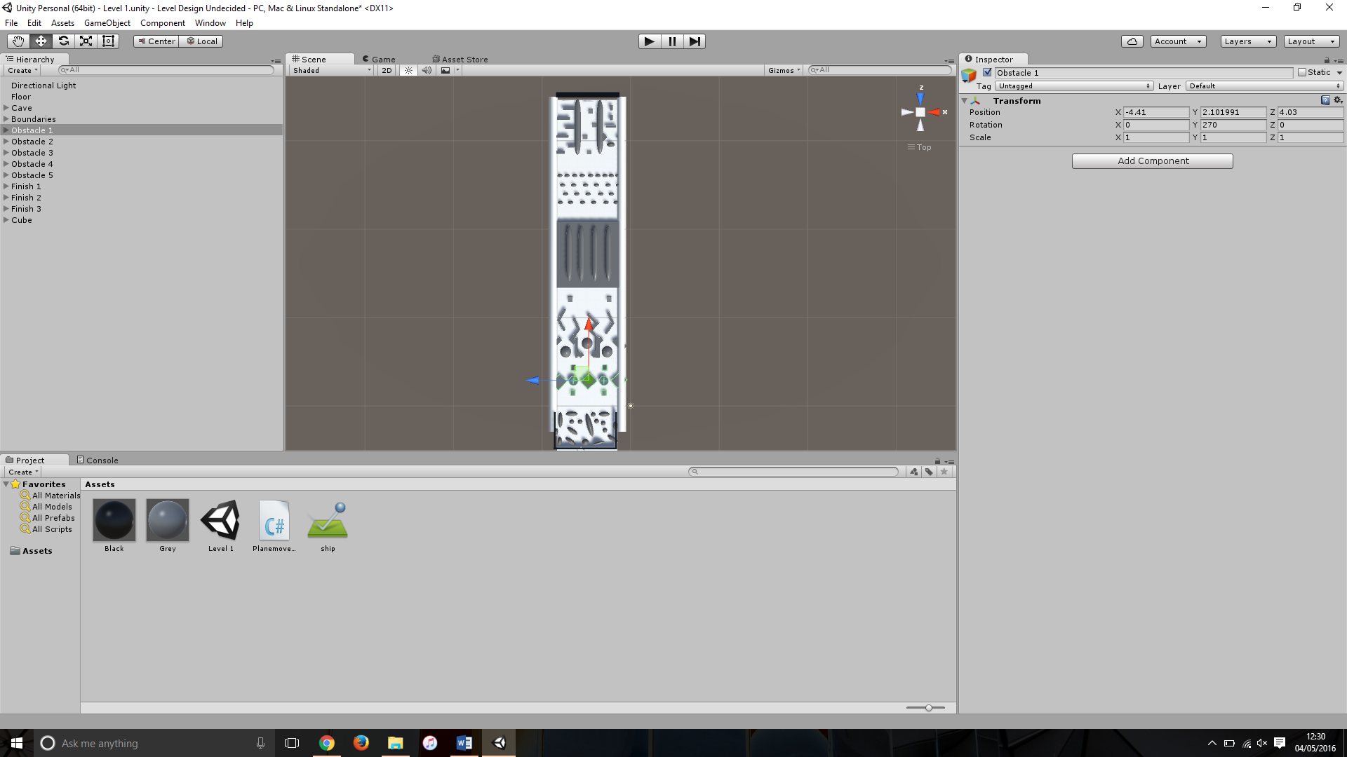The original design plans were all done on paint, with the drawn out aspects transferred into pain, these are attached to the disk handed in with this report. In the first week of the project it was essential that I got the ideas on paper and to the artist and other programmers to get their opinions. With the artists being relatively unresponsive I continued with a greybox version of the game from the original designs (pictured below) expecting them to add their own ideas for obstacles.

This greybox version was produced at the end of the second week for this project, this stayed relatively the same for the following two weeks we expected the artist would take this version and implement and models they have, then the level would be re-adjusted and extended from there according to the scaled and shape of the objects.

When I implemented the first player movement script onto the square box model we were using in place of a ship, as we hadn’t yet received this, it became clear that the spacing between the obstacles were too close together. To fix this, I extended the floor and the boundaries so the track was longer and a little bit wider, this made the game easier to get from the start to the finish (pictured above).

From the fourth week of the project I started to feel as if the artwork was going to be coming in too late to implement with appropriate time to QA the game, this meant that we were going to have to progress with the greybox ‘art style’ meaning I started paying more attention to the balancing of this version. During this week we got an un-textured version of one of the ship models the artists had been working on, I then implemented this into the game (more information available on ‘Art + Implementation’ document). Playing the game through with the new model lead to various problems that needed fixing, one of which was that the game was not long enough, the player was able to navigate through the course in under 20 seconds which I felt was too quick, with no added input from the artist regarding obstacles I took it upon myself to think up ways of making the course 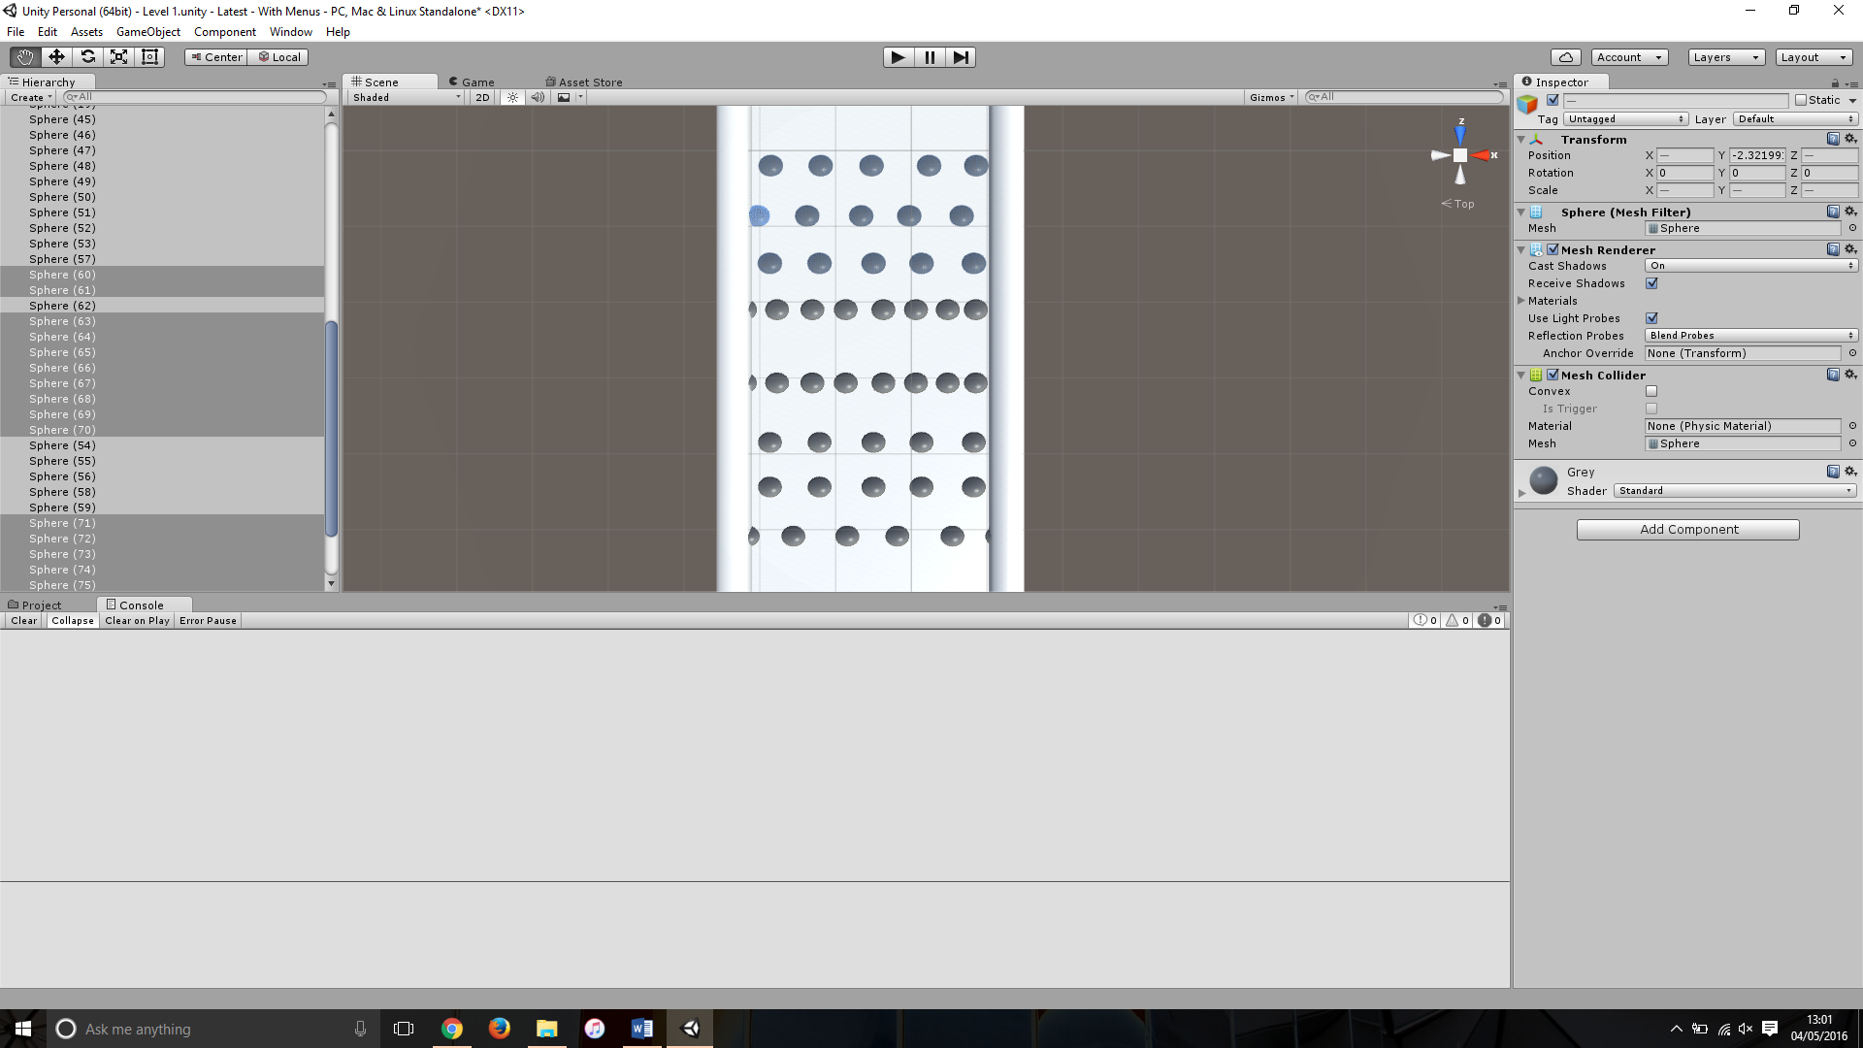longer. The progress is pictured below.

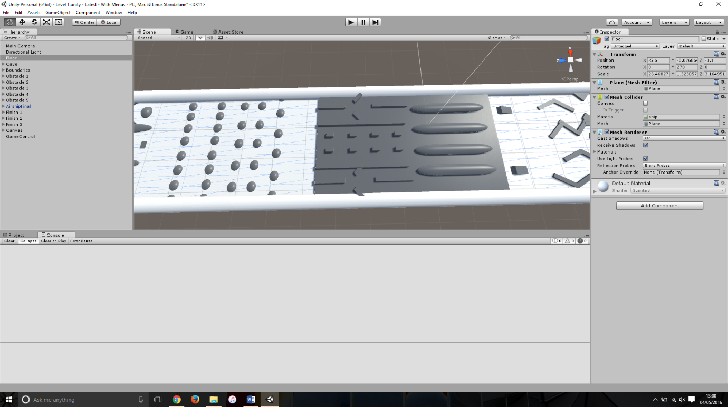

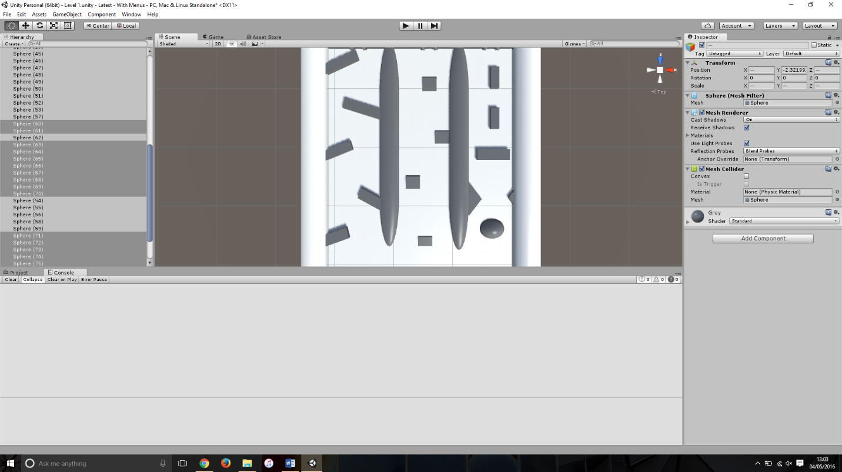

Along with the changes made to the obstacles the course was again widened and elongated as the model that was given to us was a lot wider than the box we were testing with before. This also gave room for the new parts of the obstacles to be added.

One area that required a lot of attention was the ramps, there is more detail on this in the bug reports but as the game kept updating the speed of the ship would change, this meant that the ramps would need changing as it wouldn’t be able to make it onto the intended platform or up the ramp at all. This meant the ship and level design needed to be balanced in coordination for player’s maximum enjoyment.

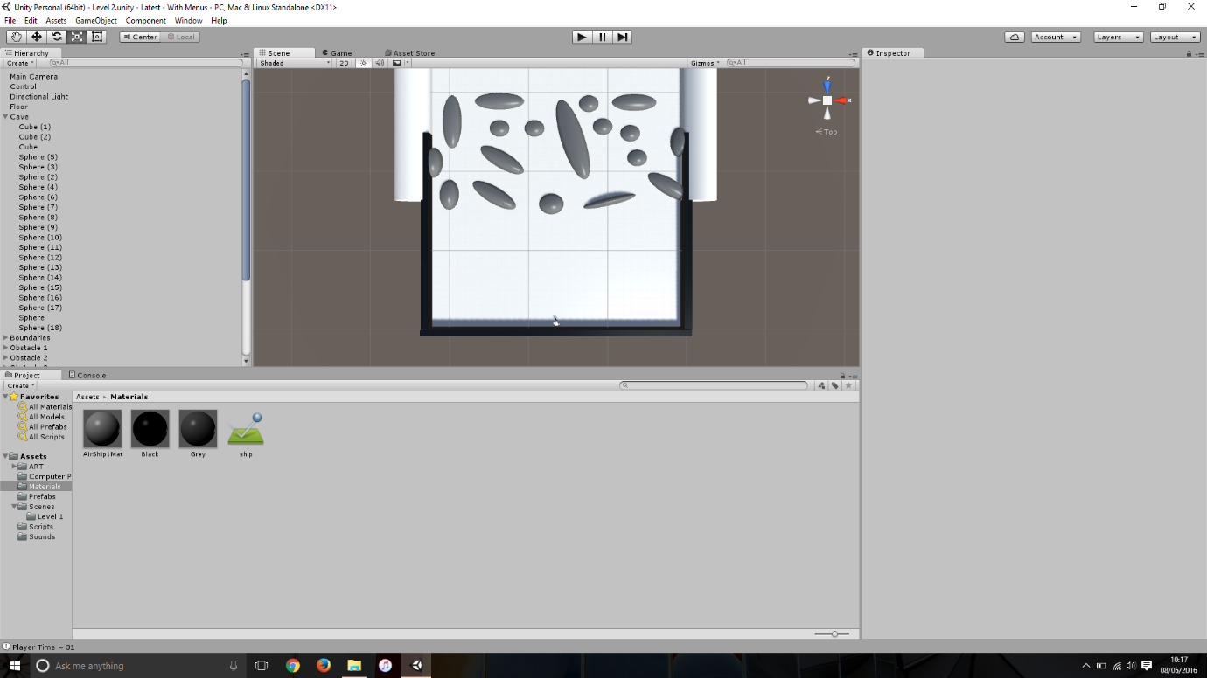This picture is showing a change that I implemented towards the end of development, after giving the game to a few people outside of the project they fed back to me that the start of the track is to crowded and makes the game too hard to start with, also cutting off the right side of the track as this was nearly unreachable. After this feedback I extended the start of the ‘Cave’ as this will give time for the player to adjust to the play settings and allow the player to go to either side of the track.

Another change I made after feedback is pictured below, this was after users said this section was too easy and a bit samey. The original idea for this section was to place pickups close to the edge of the obstacles for a risk vs reward scheme but this didn’t eventually come to be implemented. So to make this section more interesting for the user I added the blocks pictured below.

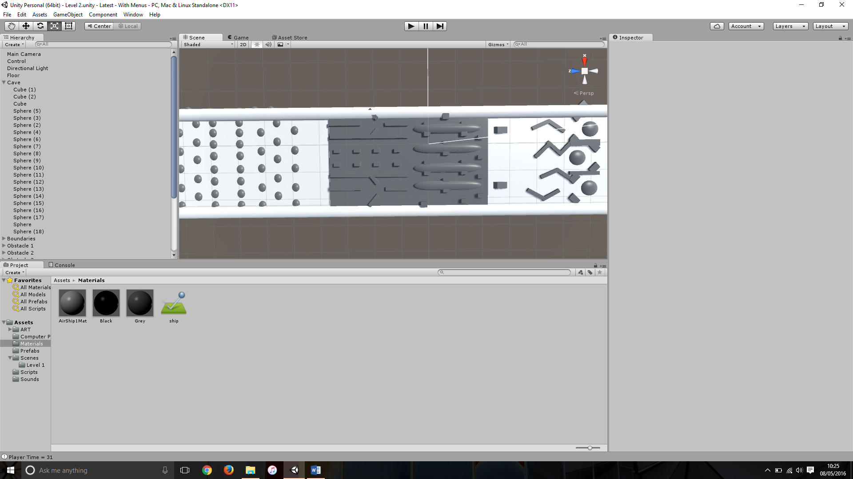

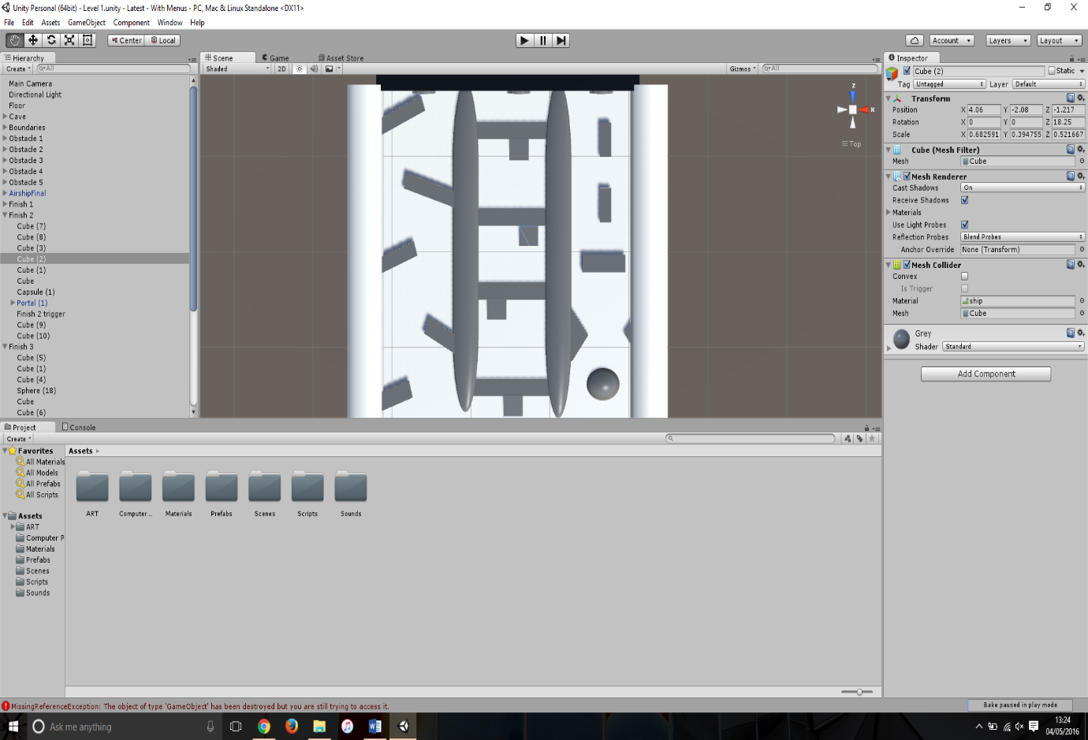The final change I made to level design was in the penultimate week, because I was still holding on for artists to give us models and textures I held off from finishing the design of the level. The final change was to change the floor that would originally destroy the ship at the end, I changed these to mini blockades that you have to go up the ramp to get past. This is pictured below.

As I was taking on level design I felt best positioned to be implementing the code with the creators because this would mean when they have attached the code to the correct objects I could re-balance the game straight away. This also meant I could see from a very early stage any problems the update would cause the game, an example of this is ‘Bug 3’ which is attached to the student CD.